VISVESVARAYA TECHNOLOGICAL UNIVERSITY, BELAGAVI
DBMS Project Assignment (BCS403)
“Local Marketplace for Convenient & Fast Online Shopping”
Submitted in partial fulfillment for the award of Degree of,
BACHELOR OF ENGINEERING
IN
COMPUTER SCIENCE & ENGINEERING
By
Student Name 1 : Faizahmed A Sayyad USN : 2BU24CS040
Student Name 2 : Faizan A Momin USN : 2BU24CS041
Student Name 3 : Ganesh S Hidaduggi USN : 2BU24CS043
Student Name 4 : Mallikrehan R Dubbal USN : 2BU24CS060
Under the Guidance of
Mrs.Akilabanu Pathan
Assistant Professor

DEPARTMENT OF COMPUTER SCIENCE & ENGINEERING
Accredited by NBA
S.S EDUCATION TRUST
S. G. BALEKUNDRI INSTITUTE OF TECHNOLOGY
2025-2026

2025 – 2026
S. G. BALEKUNDRI INSTITUTE OF TECHNOLOGY
Shivabasavanagar, Belagavi-10, Karnataka.

DEPARTMENT OF COMPUTER SCIENCE & ENGINEERING
Accredited by NBA

CERTIFICATE

This is to certify that the DBMS Assignment entitled “ Local Marketplace for Convenient & Fast Online Shopping ” has been successfully completed by

Student Name 1 : Faizahmed A Sayyad USN : 2BU24CS040
Student Name 2 : Faizan A Momin USN : 2BU24CS041
Student Name 3 : Ganesh S Hidaduggi USN : 2BU24CS043
Student Name 4 : Mallikrehan R Dubbal USN : 2BU24CS060

the bonafide students of DEPARTMENT OF COMPUTER SCIENCE & ENGINEERING, S. G. BALEKUNDRI INSTITUTE OF TECHNOLOGY of the VISVESVARAYA TECHNOLOGICAL UNIVERSITY, BELAGAVI during the year 2025–2026. It is certified that all corrections/suggestions indicated for Internal Assessment have been incorporated in the report. The DBMS Project Assignment Work (BCS403) has been approved as it satisfies the academic requirements prescribed for the Bachelor of Engineering Degree.

Mrs. Akilabanu Pathan Dr. Anil Korishetti Dr. B. R. Patagundi
Project Guide Head of the Department Principal

ACKNOWLEDGEMENT

It is our privilege to express our sincere gratitude to all those who have guided and supported us in the successful completion of this DBMS (BCS403) Course Project Assignment.

We express our heartfelt thanks to our Course Coordinator, Mrs.Akilabanu Pathan, for her valuable guidance, continuous support, and insightful suggestions throughout the development of this project. Her encouragement and direction greatly helped us in understanding and implementing various machine learning concepts effectively.We also extend our sincere thanks to the Course Coordinator for organizing and structuring this project assignment as part of Continuous Internal Evaluation, providing us an opportunity to gain practical exposure to real-world machine learning applications.

We are grateful to Dr. Anil Korishetti, Head of the Department, Computer Science and Engineering, S.G.B.I.T., Belagavi, for his constant support, encouragement, and valuable suggestions during the course of this work.

We would like to express our sincere thanks to the Principal, Dr. B. R. Patagundi, and the Management of S. G. Balekundri Institute of Technology, Belagavi, for providing the necessary infrastructure, facilities, and a conducive learning environment to carry out this project.

We also thank all the teaching and non-teaching staff of the Department of Computer Science and Engineering for their support and cooperation.
STUDENT NAME 1 : Faizahmed A Sayyad | USN : 2BU24CS040
STUDENT NAME 2 : Faizan A Momin | USN : 2BU24CS041
STUDENT NAME 3 : Ganesh S Hidaduggi | USN : 2BU24CS043
STUDENT NAME 4 : Mallikrehan R Dubbal | USN : 2BU24CS060
Finally, we express our deep gratitude to our parents and friends for their constant encouragement, motivation, and support throughout the completion of this project
ABSTRACT

- The advancement of digital technology and the widespread adoption of e-commerce have significantly changed the way people purchase goods and services. Despite this growth, many local businesses still face challenges in reaching customers through online platforms due to limited digital presence and technical resources. The project titled “Local Marketplace for Convenient & Fast Online Shopping” aims to develop a centralized online marketplace that connects local vendors with customers, enabling convenient and efficient online shopping within a specific locality.

- The proposed system provides a user-friendly platform where vendors can register, manage product inventories, update product information, and process customer orders. Customers can browse products, compare prices, add items to a shopping cart, place orders, and track deliveries through an intuitive interface. The platform is designed to support local businesses by increasing their visibility and providing them with opportunities to expand their customer base.

- The project utilizes a Database Management System (DBMS) to efficiently store and manage information related to users, products, vendors, orders, payments, and customer reviews. The database ensures data integrity, security, consistency, and quick retrieval of information. Features such as user authentication, inventory management, order tracking, and review systems are incorporated to enhance the overall functionality and reliability of the platform.

- By focusing on local commerce, the system reduces delivery time, promotes community-based shopping, and contributes to the growth of the local economy. The platform also offers vendors valuable insights into sales performance and inventory status through a dedicated management dashboard.

- The expected outcome of this project is a secure, scalable, and efficient online marketplace that simplifies the shopping experience for customers while empowering local businesses to participate effectively in the digital economy. This project demonstrates the practical application of database management concepts in solving real-world business challenges through an innovative e-commerce solution.

TABLE OF CONTENTS

Chapter No. | Title | Page No.
 | Acknowledgement | i
 | Abstract | ii
 | Table of Contents | iii
 | List of Figures | iv
 | List of Tables | v
1 | Introduction
1.1 | Problem Statement
1.2 | Objectives
2 | Dataset Description
2.1 | Dataset Source
2.2 | Feature Description
3 | Methodology
3.1 | Data Preprocessing
3.2 | Algorithm Used
3.3 | Model Training and Testing
4 | System Implementation
4.1 | Tools and Libraries
4.2 | Simple UI Design
5 | Results and Discussion
 | Conclusion
 | References
 | Appendix
 | Evaluation Sheet

LIST OF FIGURES

FIGURE NO. | DESCRIPTION | PAGE NO.
A.1 | Entity Relationship Diagram of Local Marketplace for Convenient & Fast Online Shopping | 27
A.2 | Home Page | 29
A.3 | User Login and Registration Page | 29
A.4 | Order Details Page | 30

LIST OF TABLES

TABLE NO. | DESCRIPTION | PAGE NO.
3.1 | Customers Table | 26
4.2 | Products Table | 26

- INTRODUCTION

- The rapid growth of information technology and internet connectivity has transformed the traditional shopping experience into a more convenient and accessible digital process. E-commerce platforms have become an integral part of modern business by enabling customers to purchase products and services from the comfort of their homes. However, while large online marketplaces dominate the digital retail sector, many local businesses continue to face difficulties in establishing an effective online presence and reaching potential customers.

- The project titled “Local Marketplace for Convenient & Fast Online Shopping” is designed to address this challenge by providing a dedicated platform that connects local vendors with customers within a specific geographical area. The system serves as a centralized marketplace where local businesses can showcase their products, manage inventory, and process customer orders efficiently. At the same time, customers can easily browse products, compare prices, place orders, and receive timely deliveries from nearby stores.

- The proposed system utilizes a Database Management System (DBMS) to organize and manage data related to users, vendors, products, orders, payments, and customer reviews. The database plays a crucial role in ensuring data consistency, integrity, security, and efficient retrieval of information. By maintaining a structured database, the platform can support multiple users and vendors while providing a seamless shopping experience.

- The platform focuses on promoting local commerce by reducing delivery times, improving product accessibility, and supporting small and medium-sized businesses in adapting to the digital economy. Various features such as user registration, product catalog management, shopping cart functionality, order tracking, and customer feedback mechanisms are incorporated to enhance usability and operational efficiency.

- This project demonstrates the practical application of database management concepts in the development of a real-world e-commerce solution. It aims to create a secure, scalable, and user-friendly marketplace that benefits both customers and local businesses while contributing to the growth of the local economy.

1.1 PROBLEM STATEMENT
- In today's digital era, customers increasingly prefer online shopping due to its convenience, accessibility, and time-saving benefits. However, many local businesses and small-scale vendors struggle to compete with large e-commerce platforms because of their limited online presence, lack of technological resources, and inability to reach a wider customer base. As a result, local vendors often lose potential customers despite offering quality products and services.
- Customers also face difficulties in discovering products available in nearby stores, comparing prices among local vendors, and obtaining accurate information regarding product availability. Existing online marketplaces primarily focus on national and international sellers, which often leads to longer delivery times, higher shipping costs, and reduced support for local businesses.
- There is a need for a centralized digital platform that connects local vendors and customers within a specific locality. Such a platform should enable vendors to showcase their products online, manage inventory efficiently, and process customer orders seamlessly. At the same time, customers should be able to search for products, compare options, place orders, and receive faster deliveries from nearby stores.
- Therefore, the proposed project, “Local Marketplace for Convenient & Fast Online Shopping,” aims to develop a database-driven e-commerce platform that promotes local businesses, enhances customer convenience, reduces delivery time, and supports the growth of the local economy through efficient and secure online transactions.

  - OBJECTIVES

The main objectives of the project “Local Marketplace for Convenient & Fast Online Shopping” are as follows:

- To develop a centralized online marketplace that connects local vendors and customers through a single digital platform.

- To provide a user-friendly shopping experience by enabling customers to easily browse, search, compare, and purchase products from nearby stores.

- To implement an efficient database management system for storing and managing information related to users, vendors, products, orders, payments, and customer reviews.

- To facilitate inventory and order management by allowing vendors to add, update, and monitor product details and customer orders in real time.

- To ensure secure and reliable transactions through user authentication, data protection mechanisms, and secure order processing.

- To reduce delivery time and improve product accessibility by promoting purchases from local businesses within the customer’s geographical area.

- To support the growth of local businesses by increasing their online visibility, expanding their customer reach, and enhancing their competitiveness in the digital marketplace.

- To provide a scalable and efficient e-commerce solution that can accommodate increasing numbers of users, products, and vendors while maintaining system performance.

- DATASET DESCRIPTION

- The Local Marketplace for Convenient & Fast Online Shopping project utilizes a structured database to store, manage, and retrieve information related to customers, vendors, products, orders, payments, and reviews. Since the system is an e-commerce platform, the dataset consists of multiple interconnected tables that support the core functionalities of online shopping and order management.

- The database is designed using the principles of Database Management Systems (DBMS) to ensure data consistency, integrity, security, and efficient retrieval of information. Each entity in the system is represented as a separate table with appropriate attributes and relationships. The database enables smooth interaction between customers and vendors while maintaining accurate records of transactions and inventory.

- The primary data maintained in the system includes customer details such as user ID, name, contact information, login credentials, and address. Vendor-related data includes vendor ID, shop name, contact details, and product information. Product data consists of product ID, product name, category, description, price, stock quantity, and product images. Order-related information stores details about customer purchases, order status, order date, and delivery information. Additionally, payment records and customer reviews are maintained to support secure transactions and feedback management.

- The database structure is designed to minimize redundancy through normalization techniques and establish relationships among different entities using primary and foreign keys. This ensures efficient data storage and supports various operations such as product search, inventory management, order processing, payment tracking, and report generation.

- The dataset used in this project serves as the foundation for implementing the online marketplace and demonstrates the practical application of relational database concepts in a real-world e-commerce environment.

  - DATASET SOURCE

- The dataset used in the Local Marketplace for Convenient & Fast Online Shopping project is a custom-generated dataset created specifically for the development and testing of the database system. Since the project focuses on designing and implementing an e-commerce platform for local businesses, the required data was collected and organized based on real-world marketplace operations and business requirements.

- The data includes information related to customers, vendors, products, orders, payments, and customer reviews. Sample records were created to simulate actual transactions occurring within a local online marketplace. Vendor details such as shop name, contact information, and product listings were generated to represent local businesses. Similarly, customer information, product categories, pricing details, stock availability, and order records were prepared to test various functionalities of the system.

- The database tables were designed using relational database principles, with data stored in a structured format to maintain consistency and integrity. Primary keys and foreign keys were used to establish relationships among entities such as Customers, Vendors, Products, Orders, and Payments. This approach ensures efficient data retrieval and supports operations such as product searching, inventory management, order processing, and transaction tracking.

- The generated dataset was used for database implementation, query execution, testing, and validation of the system. It provides sufficient records to demonstrate the working of the marketplace platform and evaluate the effectiveness of the proposed database design. The dataset can be further expanded in the future to accommodate additional vendors, products, and customer transactions as the platform grows.

  - FEATURE DESCRIPTION

The Local Marketplace for Convenient & Fast Online Shopping system consists of several features that enable efficient interaction between customers and vendors while ensuring smooth management of products, orders, and transactions. The major features of the system are described below:

1. User Registration and Authentication
The system allows customers and vendors to create accounts and securely log in using their credentials. Authentication mechanisms ensure that only authorized users can access their respective functionalities.

2. Vendor Management
Vendors can register their stores on the platform and manage their business operations. They can add new products, update product information, modify prices, and monitor available stock through a dedicated vendor dashboard.

3. Product Catalog Management
The platform maintains a comprehensive product catalog containing product names, descriptions, categories, prices, images, and stock availability. Customers can browse products easily through organized categories.

4. Search and Filtering System
Customers can search for products using keywords and apply filters based on categories, price ranges, or vendor information. This feature helps users quickly find the products they require.

5. Shopping Cart Functionality
The shopping cart allows customers to add, update, or remove products before completing a purchase. It provides a summary of selected items along with the total cost of the order.

6. Order Management
The system manages customer orders from placement to delivery. Customers can view order details and track order status, while vendors can process and update orders efficiently.

7. Payment Management
The platform records payment information and supports secure transaction processing. Payment details are stored and managed within the database to maintain transaction history and order verification.

8. Customer Reviews and Ratings
Customers can provide feedback and ratings for products and vendors based on their shopping experience. This feature helps improve transparency and assists other customers in making informed purchasing decisions.

9. Inventory Management
The system automatically updates product stock levels whenever purchases are made. Vendors can monitor inventory status and prevent issues such as overstocking or stock shortages.

10. Database Management and Reporting
The database maintains records of users, products, orders, payments, and reviews. The system supports efficient data retrieval, report generation, and administrative monitoring while ensuring data integrity and security.
These features collectively contribute to the development of a reliable, user-friendly, and efficient local e-commerce platform that benefits both customers and vendors.

- METHODOLOGY

The methodology adopted for the development of the Local Marketplace for Convenient & Fast Online Shopping system follows a systematic approach that includes requirement analysis, database design, implementation, testing, and deployment. The primary objective is to develop a database-driven e-commerce platform that efficiently manages customers, vendors, products, orders, and payments while ensuring data integrity and security.

3.1 Requirement Analysis
The first phase involves gathering and analyzing the requirements of both customers and local vendors. The functional requirements include user registration, product management, shopping cart functionality, order processing, payment management, and customer feedback. Non-functional requirements such as security, reliability, scalability, and usability are also identified to ensure effective system performance.

3.2 Database Design
A relational database is designed to store and manage all information related to the marketplace. The database consists of multiple entities including Customers, Vendors, Products, Orders, Payments, and Reviews. Relationships between these entities are established using primary keys and foreign keys to maintain referential integrity. Normalization techniques are applied to reduce data redundancy and improve database efficiency.

3.3 System Development
The system is developed by integrating the database with a user-friendly interface. Customers can browse products, place orders, and track purchases, while vendors can manage product listings and monitor inventory. The database handles data storage, retrieval, and transaction processing to ensure smooth system operation.

3.4 Testing and Validation
The developed system is tested to verify the correctness and reliability of all functionalities. Various operations such as user registration, product search, order placement, payment processing, and inventory updates are validated using sample data. SQL queries are executed to ensure accurate data retrieval and manipulation.

3.5 Performance and Security Measures
The database is optimized through indexing and efficient query execution techniques to improve performance. Security measures such as user authentication, access control, and data validation are implemented to protect sensitive information and prevent unauthorized access.

3.6 Deployment and Maintenance
After successful testing, the system is prepared for deployment. The database can be expanded to accommodate additional vendors, products, and customers as the platform grows. Regular maintenance activities such as data backup, performance monitoring, and system updates ensure long-term reliability and scalability of the application.
The adopted methodology provides a structured framework for developing a secure, efficient, and scalable local online marketplace while demonstrating the practical application of Database Management System concepts in a real-world environment.

DATA PREPROCESSING

- Data preprocessing is an essential step in the development of the Local Marketplace for Convenient & Fast Online Shopping system. It involves preparing and organizing the data before storing it in the database to ensure accuracy, consistency, and reliability. Proper preprocessing improves database performance and helps maintain data integrity throughout the system.

- The first stage of preprocessing involves data collection, where information related to customers, vendors, products, orders, payments, and reviews is gathered. Sample data is created to simulate real-world marketplace transactions and business operations.

- The collected data is then subjected to data cleaning to remove inconsistencies, duplicate records, and invalid entries. Missing values are identified and corrected wherever necessary to ensure the completeness of the dataset. Product names, customer details, and vendor information are standardized to maintain uniformity across the database.

- The next step involves data validation, where input constraints are applied to verify the correctness of data before insertion into the database. Validation rules such as unique customer IDs, valid contact information, positive product prices, and appropriate stock quantities are enforced to prevent incorrect data entry.

- After validation, the data is structured and organized into different relational tables such as Customers, Vendors, Products, Orders, Payments, and Reviews. Primary keys and foreign keys are assigned to establish relationships among the tables and maintain referential integrity.

- To improve database efficiency, normalization techniques are applied to eliminate data redundancy and ensure that information is stored in a logical and optimized manner. This process reduces storage requirements and improves query performance.

- Finally, the preprocessed data is loaded into the database and tested using SQL queries to verify successful insertion, retrieval, updating, and deletion operations. This ensures that the database is ready to support the functionalities of the online marketplace system efficiently and accurately.

  - ALGORITHM USED

As this project is based on a Database Management System (DBMS), it does not utilize machine learning algorithms. Instead, the system employs database design techniques, normalization processes, and SQL operations to efficiently manage and retrieve data. The following methods are used in the development of the Local Marketplace for Convenient & Fast Online Shopping system:

1. Entity-Relationship (ER) Modeling
ER Modeling is used to identify the entities involved in the system and define the relationships among them. The major entities include Customers, Vendors, Products, Orders, Payments, and Reviews. The ER model serves as the blueprint for designing the database structure.

2. Database Normalization
Normalization is applied to organize data efficiently and eliminate redundancy. The database is normalized up to suitable normal forms to ensure data consistency and integrity. This process reduces duplication and improves storage efficiency.

3. Relational Schema Design
The entities identified during ER modeling are converted into relational tables. Primary keys and foreign keys are defined to establish relationships between tables and maintain referential integrity throughout the database.

4. SQL Operations
Structured Query Language (SQL) is used to perform various database operations. The major SQL operations implemented in the project include:
- INSERT – To add new customer, vendor, product, and order records.
- SELECT – To retrieve information from the database.
- UPDATE – To modify existing records such as product details and order status.
- DELETE – To remove unwanted or outdated records.

5. Transaction Management
Transaction management techniques are used to ensure that database operations are executed accurately and reliably. This helps maintain data consistency during order placement, payment processing, and inventory updates.

6. Data Integrity and Validation
Integrity constraints such as Primary Key, Foreign Key, NOT NULL, and UNIQUE constraints are implemented to maintain data accuracy and prevent invalid entries within the database.
The combination of ER modeling, normalization, relational schema design, and SQL operations enables the system to efficiently manage marketplace data while ensuring reliability, security, and scalability.

  - MODEL TRAINING AND TESTING

- Although the title of this section is Model Training and Testing, the project is based on a Database Management System (DBMS) and does not involve machine learning model training. Therefore, this section focuses on the testing and validation of the database system to ensure that all functionalities operate correctly and efficiently.

- Database Testing
- The database was tested using sample records related to customers, vendors, products, orders, payments, and reviews. Various SQL queries were executed to verify the correctness of data insertion, retrieval, updating, and deletion operations. The testing ensured that all tables were properly connected through primary and foreign key relationships.

- Functional Testing
- Functional testing was performed to validate the core features of the system. The following functionalities were tested:
- User registration and login.
- Product addition, modification, and deletion.
- Product search and browsing.
- Shopping cart management.
- Order placement and order tracking.
- Payment record management.
- Customer review and rating submission.
- All functions were tested with different input scenarios to ensure accurate system behavior.

- Data Integrity Testing
- Data integrity constraints such as Primary Key, Foreign Key, NOT NULL, and UNIQUE constraints were verified to ensure that invalid or duplicate records could not be inserted into the database. This testing helped maintain consistency and reliability of the stored data.

- Query Performance Testing
- SQL queries were executed on different tables to evaluate data retrieval efficiency. The system successfully handled operations such as searching products, viewing customer orders, generating sales information, and updating inventory records with acceptable response times.

- Validation Results
- The testing results demonstrated that the database correctly manages marketplace operations and maintains accurate relationships among all entities. The system successfully supports customer transactions, vendor management, product inventory tracking, and order processing without data inconsistencies.
- Overall, the testing phase confirmed that the proposed database system is reliable, secure, and capable of supporting the functionalities required for the Local Marketplace for Convenient & Fast Online Shopping platform.
SYSTEM IMPLEMENTATION

- The implementation of the Local Marketplace for Convenient & Fast Online Shopping system focuses on developing a database-driven platform that enables efficient interaction between customers and local vendors. The system is designed using a relational database structure to manage product information, customer details, vendor records, orders, payments, and reviews. The implementation process includes database creation, table design, relationship establishment, query execution, and user interface integration.
- The database is developed using SQL and consists of multiple interconnected tables such as Customers, Vendors, Products, Orders, Payments, and Reviews. Each table is designed with appropriate attributes and constraints to ensure data integrity and consistency. Primary keys are used to uniquely identify records, while foreign keys establish relationships among different entities within the system.
- The system allows customers to register, log in, browse products, add items to a shopping cart, place orders, and track purchases. Vendors can manage product inventories, update product information, monitor stock levels, and process customer orders. The database efficiently handles all transactions and stores relevant information for future reference.
- SQL queries are implemented to perform various database operations including data insertion, retrieval, modification, and deletion. These operations enable effective management of marketplace activities and support smooth communication between customers and vendors. Validation checks and integrity constraints are incorporated to prevent invalid data entry and maintain database reliability.
- The implementation also includes mechanisms for managing payments and customer reviews. Order records are automatically linked to customer and product information, ensuring accurate transaction tracking and inventory updates. The system supports secure data storage and efficient retrieval of information whenever required.
- Overall, the implemented database system successfully fulfills the requirements of a local online marketplace by providing a structured, secure, and scalable environment for managing e-commerce operations. The implementation demonstrates the practical application of DBMS concepts in solving real-world business challenges and supporting digital commerce for local businesses.

  - TOOLS AND LIBRARIES

The development of the Local Marketplace for Convenient & Fast Online Shopping system involved the use of various software tools and technologies for database design, implementation, and management. These tools facilitated efficient development, testing, and execution of the project.

1. XAMPP
XAMPP is an open-source web server package used to create a local development environment. It provides Apache Server and MySQL Database services required for running and testing the application. XAMPP enables seamless integration between the database and the web application during development.

2. phpMyAdmin
phpMyAdmin is a web-based database administration tool used for managing MySQL databases. It provides an easy-to-use graphical interface for creating databases, defining tables, executing SQL queries, managing records, and monitoring database operations. It was extensively used for database creation and maintenance in this project.

3. Visual Studio Code (VS Code)
Visual Studio Code is a lightweight and powerful source code editor used for developing the front-end and back-end components of the application. It provides features such as syntax highlighting, code completion, debugging support, and extension integration, which improve development efficiency and code management.

4. MySQL Workbench
MySQL Workbench is a database design and administration tool used for modeling, designing, and managing the MySQL database. It supports the creation of Entity Relationship (ER) diagrams, schema design, SQL development, and database maintenance. The tool was utilized for database modeling and query execution.

5. MySQL Database
MySQL is the relational database management system used for storing and managing all project data. It maintains records related to customers, vendors, products, orders, payments, and reviews. MySQL provides data security, integrity, and efficient query processing, making it suitable for e-commerce applications.

Libraries and Technologies Used
- HTML – For designing the structure of web pages.
- CSS – For styling and improving the visual appearance of the user interface.
- JavaScript – For implementing dynamic and interactive functionalities.
- SQL – For database creation, data manipulation, and query execution.
These tools and technologies collectively contributed to the successful development and implementation of the Local Marketplace for Convenient & Fast Online Shopping system.

  - SIMPLE UI DESIGN

The Local Marketplace for Convenient & Fast Online Shopping system is designed with a simple, user-friendly, and responsive interface to provide an efficient shopping experience for both customers and administrators. The user interface focuses on easy navigation, product accessibility, and smooth order management.

Home Page
The Home Page serves as the main entry point of the application. It displays product categories, featured products, promotional offers, and a search bar for quick product discovery. Customers can browse products based on categories such as Books, Electronics, Furniture, and Fashion. The page also provides access to shopping cart functionality and order tracking services.

User Login and Registration Page
The Login and Registration Page allows users to create new accounts and securely access the system. New customers can register by providing personal information such as name, email address, contact number, and password. Existing users can log in using their credentials to access personalized features such as order history, shopping cart, and account management.

Product Browsing and Shopping Cart
Customers can view detailed information about products including product name, description, category, price, and availability. Selected products can be added to the shopping cart, where users can review their items before proceeding to checkout. The cart also displays product quantities and total order cost.

User Order Management
The system provides a dedicated order management section where customers can view their order history and track the status of placed orders. Information such as order details, purchased products, order dates, and delivery status is displayed to enhance transparency and user convenience.

Admin Dashboard
The Administrator Dashboard enables efficient management of the marketplace. The administrator can create categories and subcategories, manage products, monitor users, and oversee overall system activities. The dashboard provides centralized control over marketplace operations and database records.

Product Management Interface
The Product Management Module allows administrators to add, update, and delete product information. Details such as product name, category, company name, pricing, shipping charges, stock availability, product description, and product images can be managed through an intuitive form-based interface.

Order Details and Tracking
The Order Details page provides comprehensive information about customer purchases. It displays customer information, shipping address, billing details, product details, order quantity, total amount, and order status. Administrators can update order progress and monitor the delivery process effectively.
The overall user interface is designed to ensure simplicity, accessibility, and efficient interaction between customers, vendors, and administrators. The responsive design enhances usability across different devices and contributes to a smooth online shopping experience.
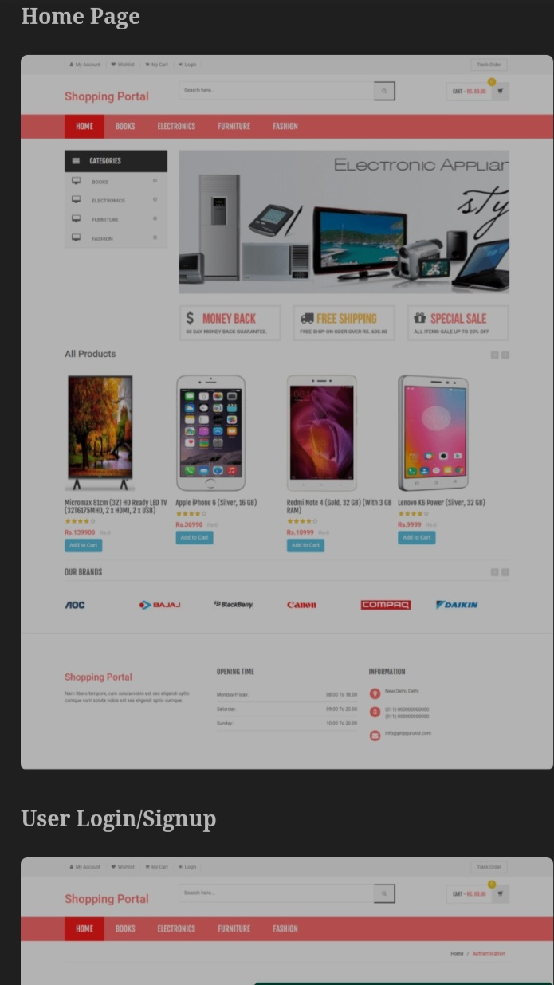

- RESULTS AND DISCUSSION

- The implementation of the Local Marketplace for Convenient & Fast Online Shopping system successfully demonstrates the application of Database Management System concepts in developing an efficient e-commerce platform for local businesses and customers. The developed system provides a centralized marketplace where users can browse products, place orders, manage transactions, and track purchases through a user-friendly interface.

- The database was successfully designed and implemented using MySQL, with multiple relational tables representing Customers, Vendors, Products, Orders, Payments, and Reviews. Relationships between these tables were established using primary and foreign keys, ensuring data integrity and consistency throughout the system.

- During testing, all major functionalities of the system operated successfully. Customers were able to register accounts, log in securely, browse product categories, search for products, add items to the shopping cart, and place orders without errors. Vendors and administrators could efficiently manage products, update inventory, monitor customer orders, and maintain marketplace operations.

- The SQL queries executed during testing produced accurate results for data insertion, retrieval, updating, and deletion operations. Database constraints and validation mechanisms effectively prevented invalid data entry and maintained the reliability of stored information.

- The graphical user interface provided smooth navigation and enhanced user experience. The Home Page, User Registration Page, Product Management Page, User Orders Page, and Order Details Page functioned as expected and enabled efficient interaction between customers and vendors.

- The project also demonstrated the advantages of local e-commerce by reducing product search time, improving accessibility to nearby stores, and supporting faster order processing. The database structure proved scalable and can accommodate future expansion involving additional products, vendors, and customers.

- Overall, the results indicate that the proposed system successfully fulfills its objectives by providing a secure, reliable, and efficient online marketplace for local businesses. The project validates the effectiveness of relational database design and demonstrates how DBMS concepts can be applied to solve real-world e-commerce challenges.

CONCLUSION

The Local Marketplace for Convenient & Fast Online Shopping project was successfully designed and implemented as a database-driven e-commerce platform that connects local vendors with customers through a centralized online marketplace. The system demonstrates the effective application of Database Management System concepts, including database design, normalization, relationship management, and SQL-based data operations.
The developed platform provides essential functionalities such as user registration, product management, shopping cart operations, order processing, payment management, and customer feedback. By utilizing a relational database structure, the system ensures efficient data storage, retrieval, integrity, and security while supporting smooth interaction between customers and vendors.
The project addresses the challenges faced by local businesses in establishing an online presence and enables them to reach a wider customer base. At the same time, customers benefit from convenient product discovery, faster order processing, and improved access to products available within their locality. The implementation of database constraints and validation mechanisms further enhances the reliability and consistency of the system.
Testing results confirmed that all major functionalities operate correctly and that the database efficiently manages marketplace transactions and records. The system is scalable and can be expanded in the future to accommodate additional vendors, products, advanced payment gateways, delivery tracking services, and enhanced recommendation features.
In conclusion, the project successfully achieves its objective of creating a secure, reliable, and user-friendly online marketplace that promotes local commerce and demonstrates the practical importance of Database Management Systems in real-world e-commerce applications.

REFERENCES

[1] A. Hernawan, R. Komarudin, and N. Afni, “Analisa Perbandingan Kualitas Pelayanan Web E-Commerce Terhadap Kepuasan Konsumen Menggunakan WebQual 4.0,” Jurnal Ilmiah Teknologi Informasi Asia, vol. 15, no. 1, pp. 39–48, Apr. 2021.

[2] D. Kaur and H. Kaur, “Usability and Performance Analysis of E-Commerce Websites,” Asian Journal of Computer Science and Technology, vol. 9, no. 1, pp. 1–7, May 2020.

[3] M. Shi and H. Yuan, “Impact of E-Commerce Website Usability on User Satisfaction,” Journal of Advanced Computational Intelligence and Intelligent Informatics, vol. 23, no. 1, pp. 91–96, Jan. 2019.

[4] L. Hasan, “Key Design Characteristics for Developing Usable E-Commerce Websites,” Informing Science: The International Journal of an Emerging Transdiscipline, vol. 19, pp. 253–275, 2016.

[5] C. Changchit and T. Klaus, “An Exploratory Study on Small Business Website Creation and Usage,” Journal of Electronic Commerce in Organizations, vol. 13, no. 1, pp. 1–14, 2015.

[6] T. Beal and M. A. Abdullah, “SMEs and Their E-Commerce,” Industry and Higher Education, vol. 19, no. 3, pp. 259–269, Jun. 2005.

[7] R. Elmasri and S. B. Navathe, Fundamentals of Database Systems, 7th Edition, Pearson Education, 2017.

[8] A. Silberschatz, H. F. Korth, and S. Sudarshan, Database System Concepts, 7th Edition, McGraw-Hill Education, 2020.

[9] P. J. Deitel and H. M. Deitel, Internet and World Wide Web: How to Program, 5th Edition, Pearson Education, 2012.

[10] Oracle Corporation, “MySQL Documentation,” Available: https://dev.mysql.com/doc/. Accessed: May 2026.

APPENDIX

The appendix contains supporting materials, database design details, SQL queries, and implementation screenshots that were used during the development of the Local Marketplace for Convenient & Fast Online Shopping project.
Appendix A – Database Schema
The database schema consists of the following tables:

- Customers
- Vendors
- Products
- Categories
- Orders
- Order Details
- Payments
- Reviews

The tables are connected using primary keys and foreign keys to maintain referential integrity and ensure efficient data management.

Sample Tables

Customers Table
Field Name | Data Type | Description
Customer_ID | INT | Unique customer identifier
Name | VARCHAR(100) | Customer name
Email | VARCHAR(100) | Email address
Contact_No | VARCHAR(15) | Contact number
Password | VARCHAR(100) | User password
Address | TEXT | Customer address

Products Table
Field Name | Data Type | Description
Product_ID | INT | Unique product identifier
Product_Name | VARCHAR(100) | Product name
Category_ID | INT | Category reference
Price | DECIMAL | Product price
Quantity | INT | Available stock
Description | TEXT | Product details

Appendix B – ER Diagram

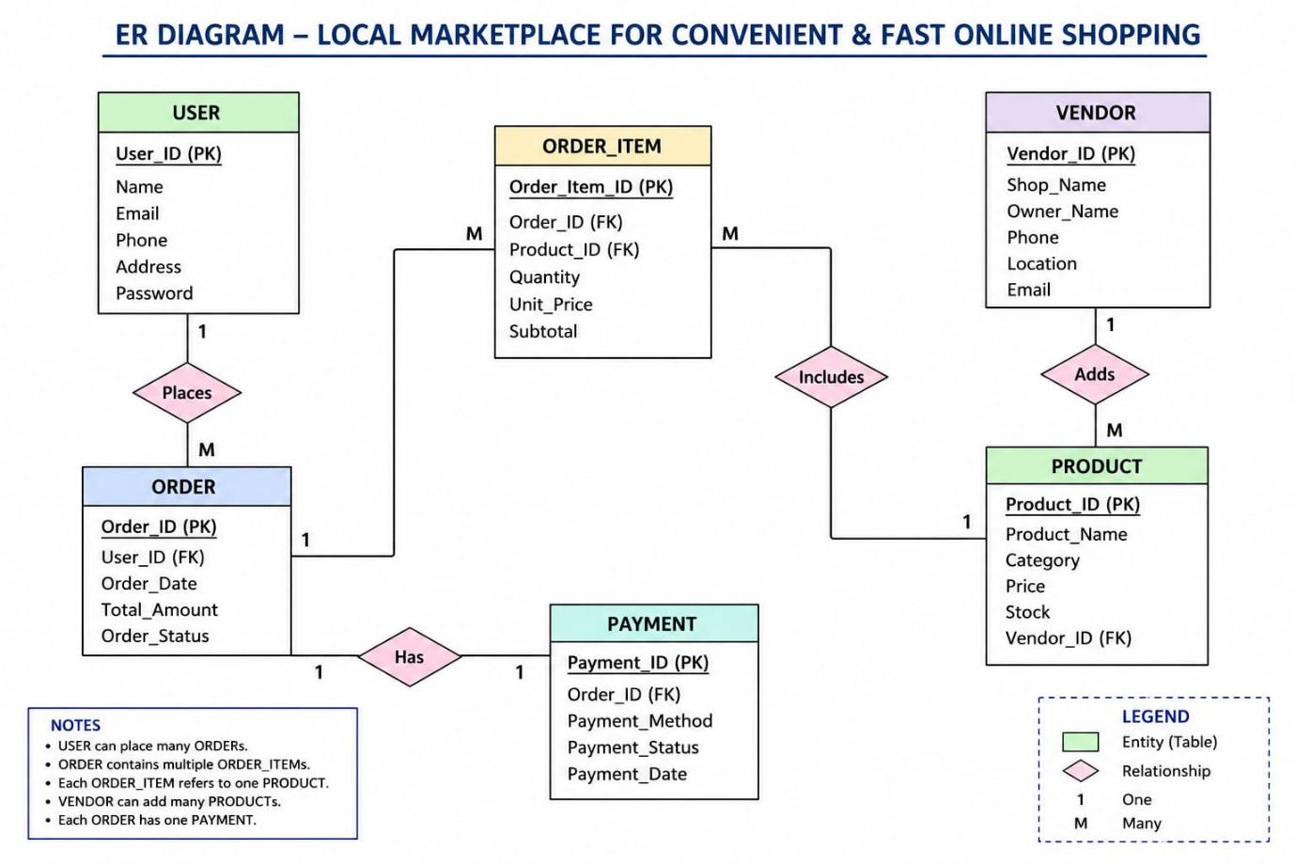

Figure A.1: Entity Relationship Diagram of Local Marketplace for Convenient & Fast Online Shopping

Appendix C – SQL Queries

Create Database
CREATE DATABASE LocalMarketplace;
USE LocalMarketplace;

Create Customer Table
CREATE TABLE Customers(
Customer_ID INT PRIMARY KEY AUTO_INCREMENT,
Name VARCHAR(100),
Email VARCHAR(100),
Contact_No VARCHAR(15),
Password VARCHAR(100),
Address TEXT
);

Insert Sample Data
INSERT INTO Customers
(Name, Email, Contact_No, Password, Address)
VALUES
('Amit Kumar','amit@gmail.com',
'9876543210','12345',
'Belagavi');

Retrieve Customer Data
SELECT * FROM Customers;

Update Customer Information
UPDATE Customers
SET Contact_No='9999999999'
WHERE Customer_ID=1;

Delete Customer Record
DELETE FROM Customers
WHERE Customer_ID=1;

Appendix D – System Screenshots

Figure A.2 Home Page


Figure A.3 User Login and Registration Page

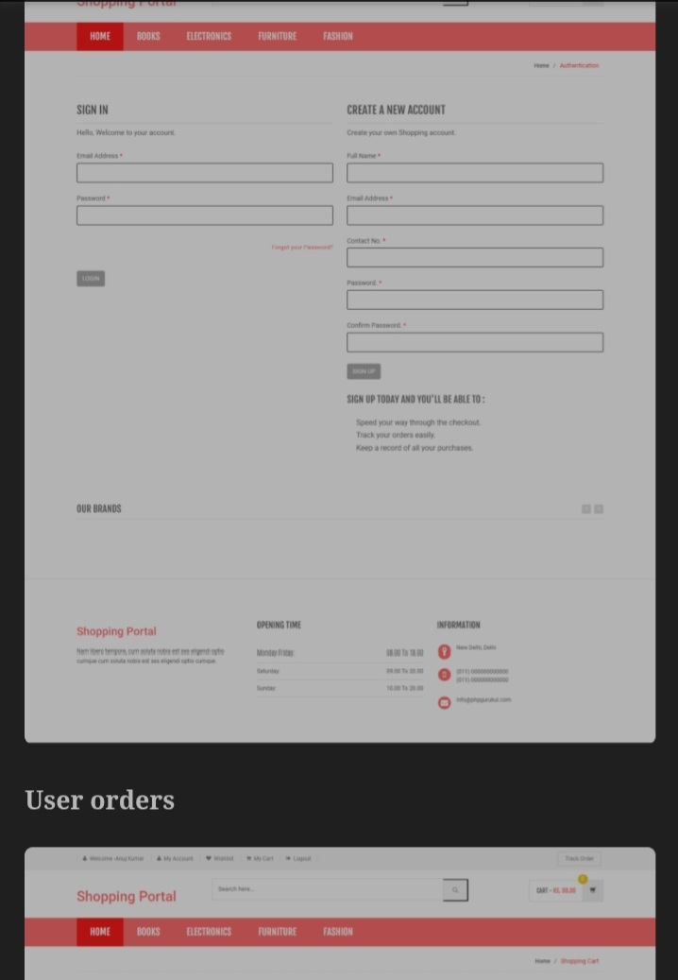
Figure A.4 Order Details Page

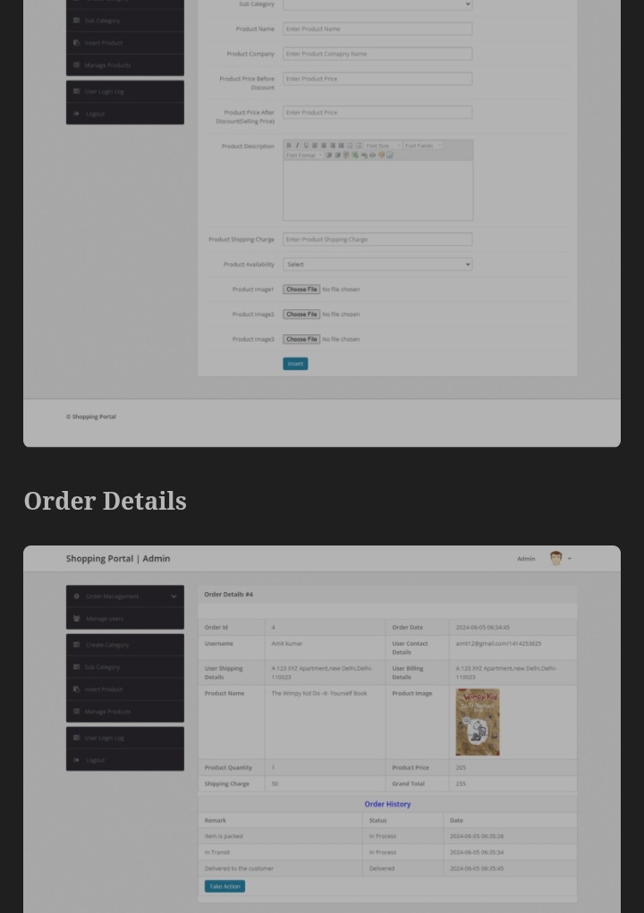

Appendix E – Software and Hardware Requirements

Hardware Requirements

- Processor: Intel Core i3 or above
- RAM: 4 GB or higher
- Storage: 100 GB available disk space
- Internet Connection

Software Requirements

- Operating System: Windows 10/11
- XAMPP Server
- phpMyAdmin
- MySQL Database
- MySQL Workbench
- Visual Studio Code
- Web Browser (Chrome, Firefox, Edge)

The appendix provides additional technical information and supporting materials that validate the design,


ISO 21001:2018
certified institute
S. S. Education Trust’s CET Code: E-175 (UG)/T-942 (PG)

S. G. BALEKUNDRI INSTITUTE OF TECHNOLOGY
Shivabasavanagar, Belagavi- 590 010, Karnataka- India
Office: 0831-2407172, 2554559 Fax: 0831-2407152 Website: www.sgbit.edu.in

Department of Computer Science & Engineering
Email: hod-cs@sgbit.edu.in, Accredited by NBA Department Extension: 532

DBMS Assignment (BCS403) - AY:2025-2026
Team Evaluation Sheet (Total: 25 Marks)
Team No : 7
Project Title : Local Marketplace for Convenient & Fast Online Shopping
Component Evaluation Criteria | Excellent 4–5 marks | Good 3–4 marks | Average 2–3 marks | Poor 0–2 marks | Max Marks | USN:  2BU24CS040  Name:  Faizahmed A Sayyad | USN:  2BU24CS041  Name:  Faizan A Momin | USN:  2BU24CS043  Name:  Ganesh S Hidaduggi | USN:  2BU24CS060  Name:  Mallikrehan R Dubbal
Problem Understanding & Database Design | Problem clearly defined with ER model, schema design, normalization, and architecture | Problem defined with reasonable database design | Basic understanding with weak schema design | Problem unclear with improper database design | 5
Database Implementation using SQL / SQLite / MongoDB | Effective implementation using SQL, SQLite, MongoDB with proper collections/tables and queries | Database concepts implemented with minor limitations | Basic implementation with limited functionality | Little or no use of database concepts | 5
CRUD Operations & Query Execution | Proper CRUD operations, joins/queries, and data handling working effectively | CRUD operations working with basic query execution | Limited database operations implemented | No proper database functionality | 5
User Interface / Frontend | Functional and user-friendly interface with proper input/output | Functional interface but limited features | Basic interface with minimal usability | No interface or incomplete implementation | 2
Project Presentation | Clear explanation, well-structured presentation, and confident demo by both members | Good explanation with minor gaps | Limited clarity or incomplete explanation | Poor presentation or unclear explanation | 3
Project Report & Viva | Well-structured report, clear diagrams, and strong answers in viva | Good documentation with acceptable answers | Basic report with limited understanding during viva | Poor report and unable to answer questions | 5
Total Marks |  |  |  |  | 25

Course Coordinator
Mrs. Akilabanu Chikkumbi

